Warehouse Registration & Offering System
under
Joint Venture Scheme
(NEW SYSTEM HOSTED ON MPWLC WEBSITE)

MP State Warehousing and

USER MANUAL
Ver 1.0
February 2018

Logistics Corporation
MP State Warehousing and Logistics Corporation
Office Complex , Block 'A'
Gautam Nagar,
Bhopal (M.P)

BACKGROUND

MPWLC is in continues process to transform the service delivery by introducing efficiency in its processes. These changes will be helpful to the concerned stakeholders in long run. In compliance of the same, a new application has been developed for Warehouse / Godown Owners to register their Warehouse / Godown under Joint Venture Scheme (JVS) to offer the capacities for storage in various crop seasons. Previously these activities were undertaken by third party portal.

SCOPE OF DOCUMENT

This User manual covers the activities to be undertaken by the applicants (such as Warehouse / Godown Owners) to register their Warehouse / Godown under Joint Venture Scheme (JVS) and then offer the storage capacities. It also contains the payment process for Registration and Offer fees.

REGISTRATION FORM ENTRY

With the launch of the new Application for Warehouse Registration & Offering System, all previous registrations are now NOT VALID to receive any offer for storage from MPWLC.

All interested Warehouse / Godown Owners must have to REGISTER their Warehouse / Godown in this system again to provide any offer to MPWLC. Applications received through this application will only be considered.

In order to register themselves, All interested Warehouse / Godown Owners must go to the link available in MPWLC official website http://mpwarehousing.com/ and click the URL http://mpsc.mp.nic.in/warehouse/JointVentureScheme/JointVentureSchemeApp.aspx

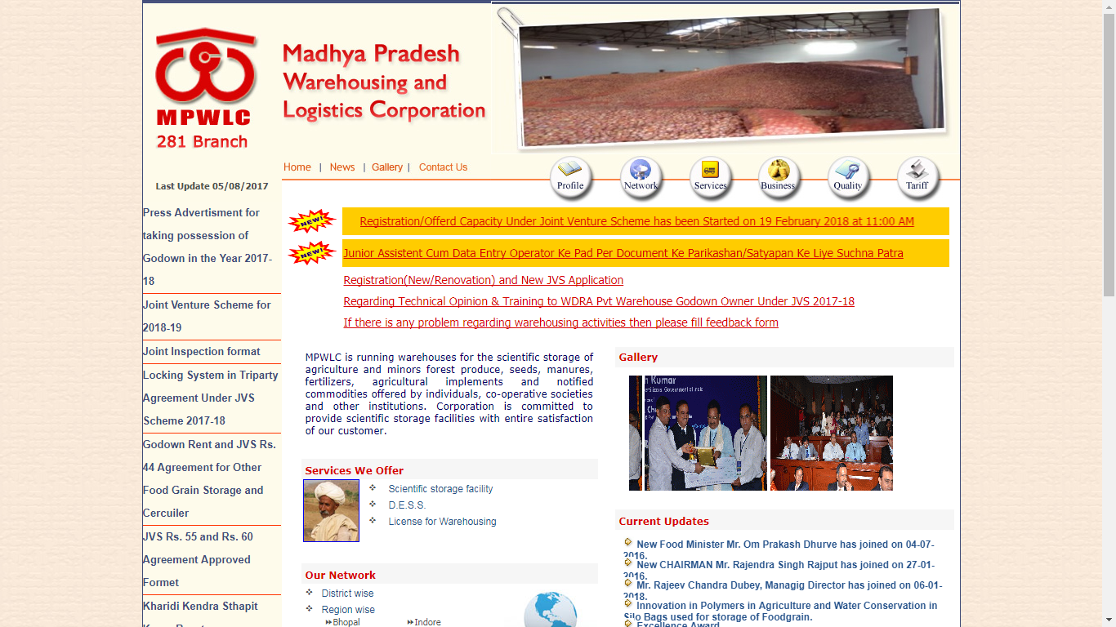

This screen will open where all instructions are listed. Users are advised to go through the instructions very carefully and apply the same in application filing process. User has to first create his / her login to proceed for registration by clicking the link (Registration form – Login) as shown above.

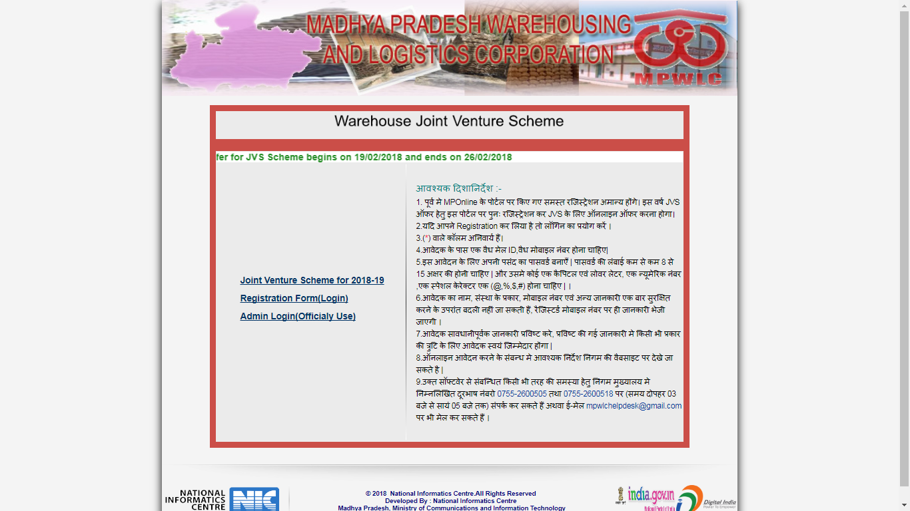

On clicking the Registration form – Login, the following screen will be opened for registration.

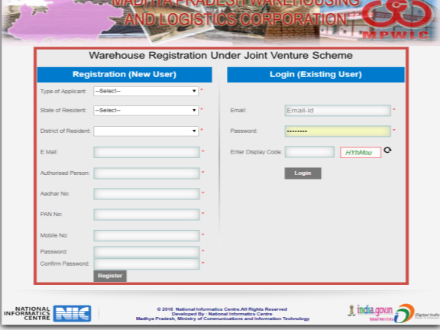
User must be a Godown Owner and has to fill up his/ her details for this login. The fields mentioned in this form are mandatory in nature. It contains the personal information of Godown owner such as Name of Authorised Person, his/ her Aadhaar Number, PAN, email and Mobile number.

He/ She also select the Type of applicant and District of residence. Users also have to enter the password and confirm the same by re-entering. By this process a User ID will be created for the given mail id and entered password.

Once user login in to the system, the following screen will be opened.

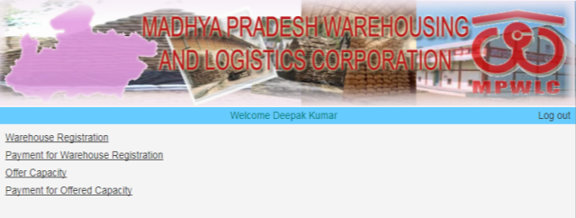

This screen will allow user to register their warehouse / Godown with MPWLC.

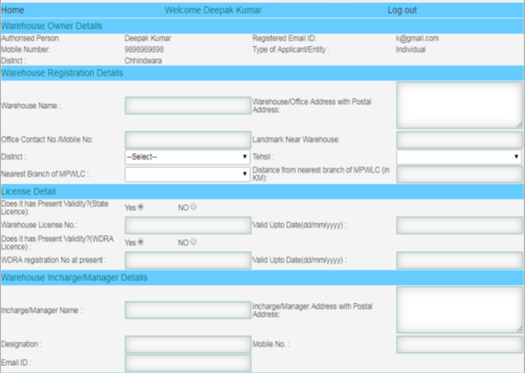

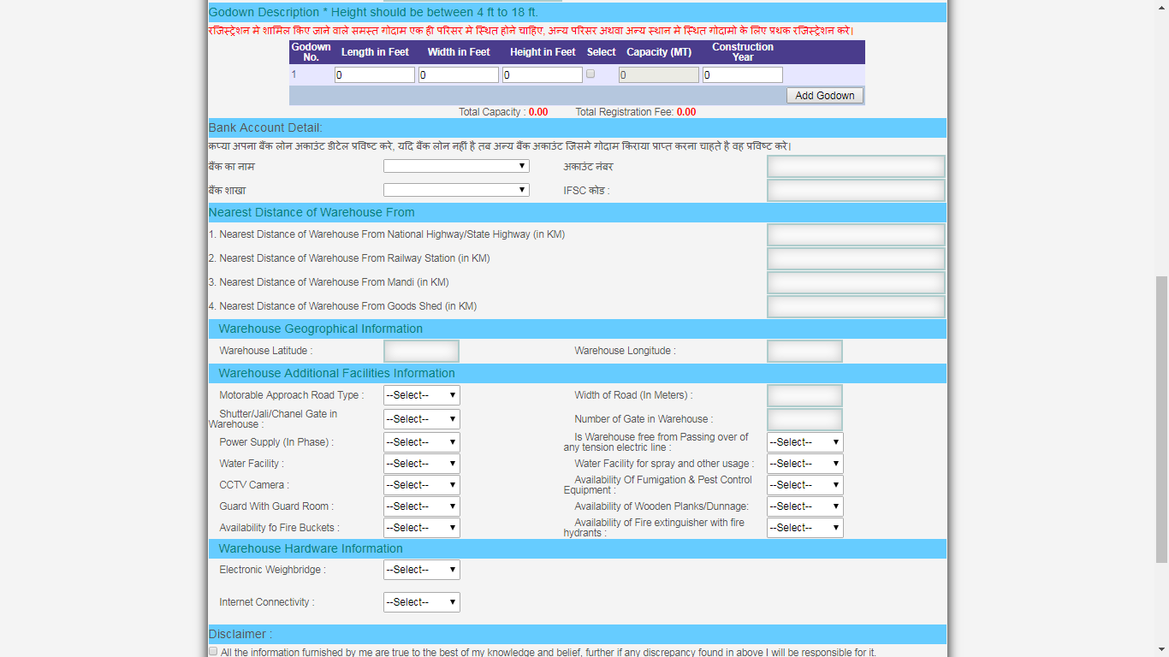
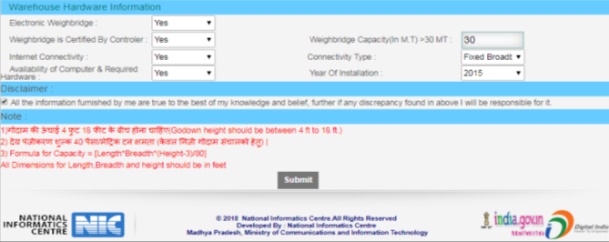

This screen has few sections which user has to fill up with proper information.

- Warehouse Registration Details – User has to enter the correct name of Warehouse, its office address and postal address, Contact number / mobile number , Landmark Near Warehouse / Godown, District, Tehsil, Nearest Branch of MPWLC, Distance from nearest branch of MPWLC [in KM]

- License Details - User has to enter the correct details of Licences available
- State License - Does it has Present Validity?( State License) (Yes /No), Warehouse License No, Valid Up Date ( select from date picker only)

- WRDA License - Does it has Present Validity?(WDRA License)(Yes /No), WDRA registration No at present, Valid Up Date ( select from date picker only)

User may proceed further only if he has one valid licence from above mentioned two licenses.

- Warehouse In-charge / Manager Details - User has to enter the correct details of godown in charge such as Name of Godown In charge/ Manager, Godown In charge/ Manager Address with Postal Address, Designation, Mobile, and Email etc .

- Godown Description / Details - User has to enter the correct details of Godowns situated in a campus only. If the godown are not in one campus and situated in other places then separate registration must be filled. Such godowns which are situated in other campus or other places will be rejected. Hence this data entry needs utmost care.

Here user may enter ore than one godown available in campus and enter their length, width and Height in Feet Only. The system will accept maximum height only up to 18 Feet. Hence even the height of godown is more than 18 feet; user has to enter 18 feet only. Capacity will be automatically calculated by the system and user has to enter the construction year only.

All godowns in a campus can be added through this part of screen. Godown entered here only will be eligible for offering in next step. Also once submitted, no change in information is possible.

- Bank Account Details - User has to enter the correct details of his/ her bank account. It is expected that user must enter the bank loan account details here. They may provide other bank account details only in such cases where there is no loan exist on user. This account will be used for disbursing the rental fee of the godowns.

User may select his / her bank name from given list, if his/ her does not available in list then he/ she may select the option “other” and then enter the bank account number and IFSC code.

Incorrect bank account number will lead to no payment to the godown owner in future. Hence user must enter the correct bank account and IFSC code.

- Nearest Distance of Warehouse From - User has to enter the correct distances of his/ her Warehouse / Godown from (nearest) National Highway, /State Highway, Railway Station, Mandi and Goods Shed.

- Warehouse Geographical Information: - User has to enter the correct latitude and longitude of its warehouse / godown in XX.YYYYYY and AA.BBBBBB format. This can be retrieved from any free downloadable mobile app (example Geolocation Tracker, GPS coordinate, MY GPS location, Latitude Longitude Location and many more)

- Warehouse Additional Facilities Information- User has to enter the correct details of facilities available at warehouse such as Motorable Approach Road Type , Width of road (in Metres), Shutter gate / Jali gate / Channel gate in warehouse etc .

- Warehouse Hardware Information- User has to enter the correct details of Available hardware at Warehouse such as Electronic Weighbridge and computer hardware/ Internet connectivity.

User may proceed further only if Electronic Weighbridge capacity is above 30 MT.

- Self Declaration - User has to check on the Self Declaration button to proceed further.

If any Field is left blank the user may not be able to submit the form.

Once submitted the user will get the receipt of registration details in following screen.

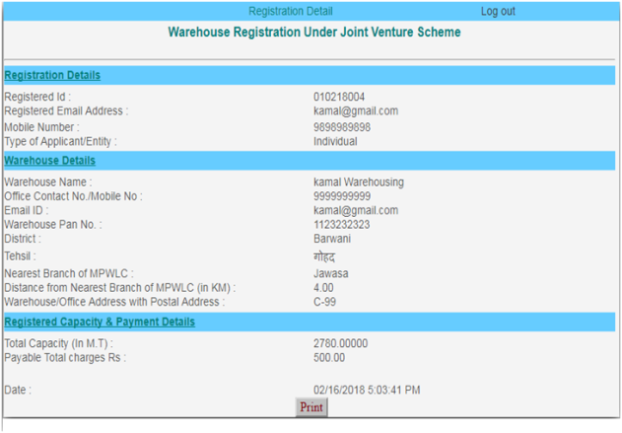
User may take print out of the same and can use it fo future references.

REGISTRATION FEE PAYMENT

In order to pay the registration fee user has to keep the copy of registration details and payment mode/ method details handy.

User has to login and open the screen or go to home button( if already logged in)

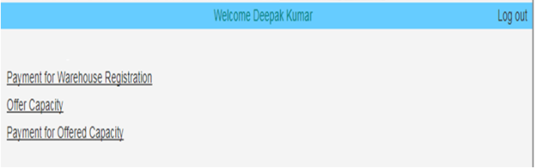

On clicking the “Payment for Warehouse Registration” following screen will open.

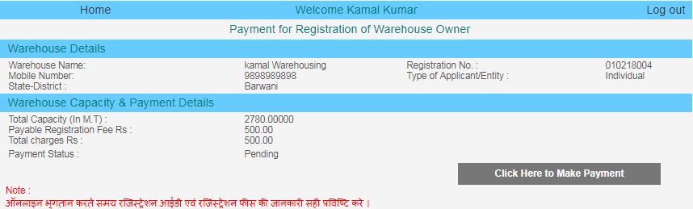

User has to click the button for Making Payment, User will be directed to SBI website as shown below .

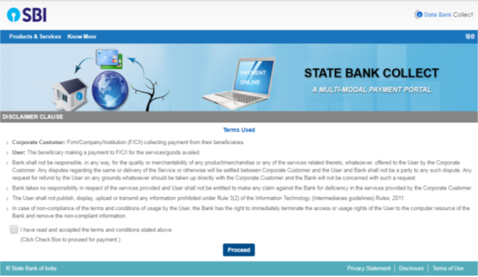

User has to check ON the check box and press the Proceed Button.
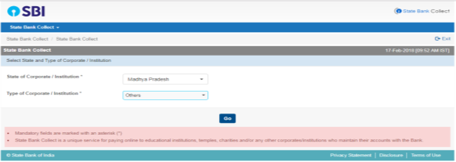

User has to select the value as follows:-

State of Corporate / Institution | Madhya Pradesh
Type of Corporate / Institution | Others

And then press GO Button.

Following screen will open
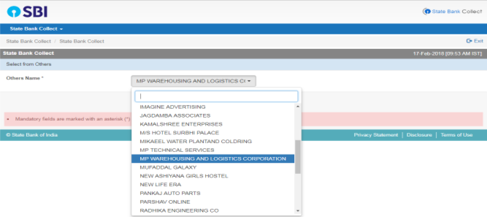
Now User has to select the value as follows:-

Others Name | MP WAREHOUSING AND LOGISTIC CORPORATION

And then press GO Button.

Following screen will open
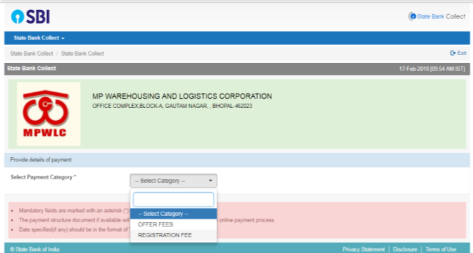
Now User has to select the value as follows:-

Select Payment Category | REGISTRATION FEE

And then press GO Button and Following screen will open

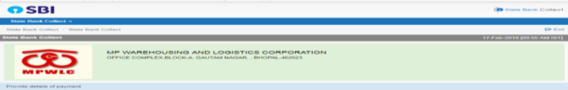
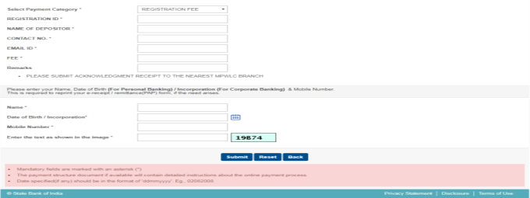

User has to enter the details of Registration Number, Name of Depaositor, Contact number, email ID, registration fee, and remarks alsong with Name, Date of Birth / incorporation, mobile number etc of the user.

Note: - User is advised to fill the correct Registration number and Fee amount as defined in Registration Recipt. Any discrepency in amount may lead the disqualification of the user.

On submission of the same, the follwing screen shows the entered details and on confirmation of the same user will be directed to proceed for payment.

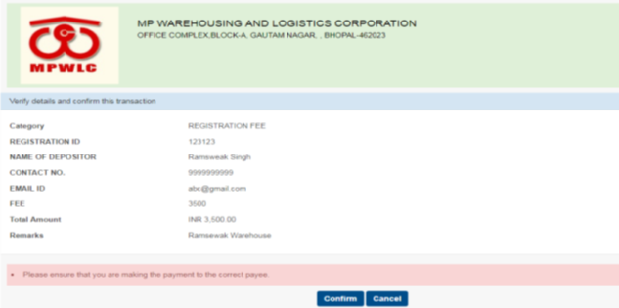
On pressing confirm button the following screen will open

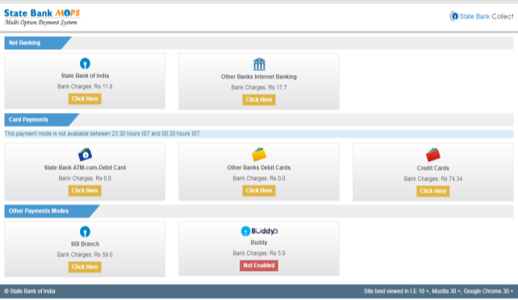

This screen provides various payment options to the user, which are as follows:-

- Net Baking
- Through Debit and Credit Cards
- Other Payment Modes such as SBI branch and SBI Buddy

- Through Net baking

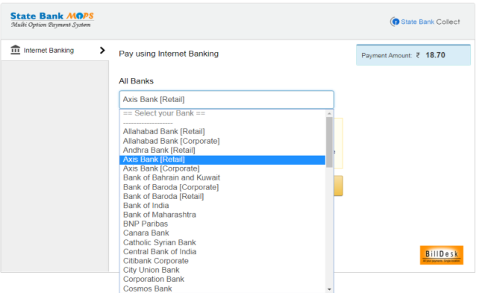
User may pay through Netbaking with this option

- Through Debit and Credit Cards

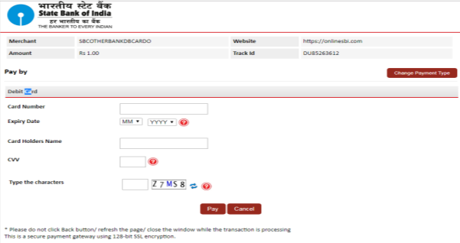

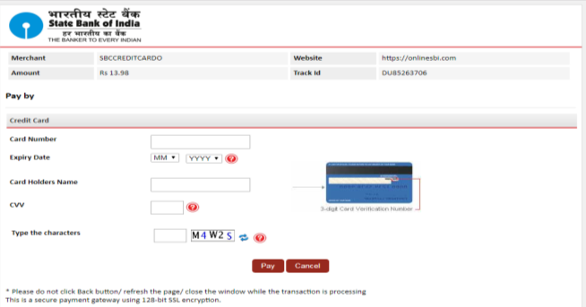

Based on any mode the user may pay the fee and on successful payment of fee the following screen will be available.

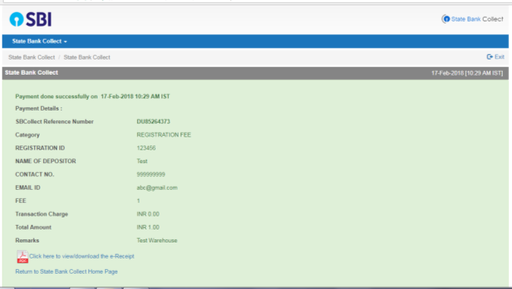

A PDF file can also be downloaded for the successful payment. User may take copy of the same for future references. For payment any query will be entertained only with valid SBCollect Reference Number.

The PDF look like as follows:-

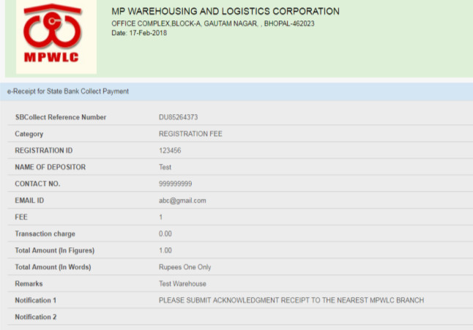

On successful completion of transaction, user may exit from the payment portal. On clicking EXIT button, the following screen will pop up.

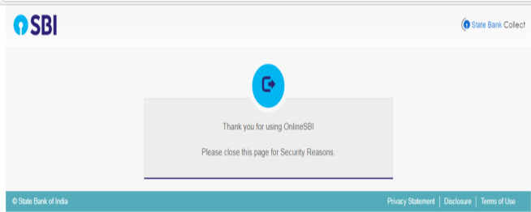

In this way the process for Payment of Registration fee will be completed.

OFFERING THE CAPACITY

Once user has registered the Warehouse / Godown and Paid the registration Fee successfully, he / she is now able to offer the capacity of such Warehouse / Godown only.

User has to login and open the screen or go to home button( if already logged in), the Home screen will look like as follows:-

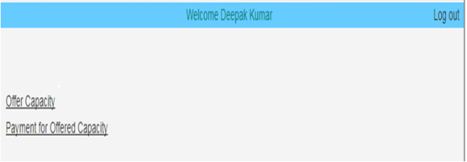

The offer Screen will be opened as follows:-
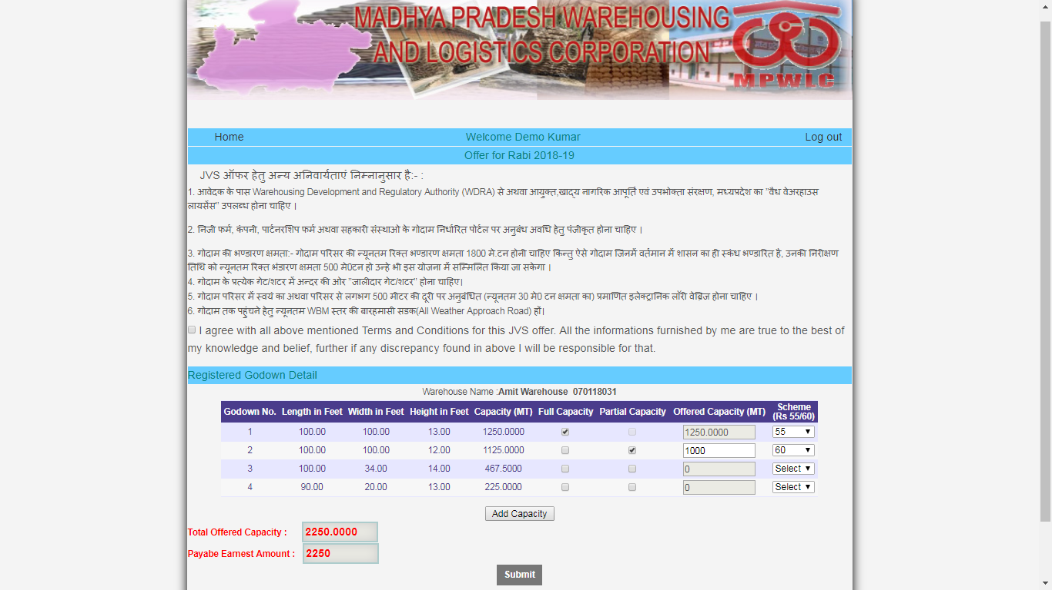

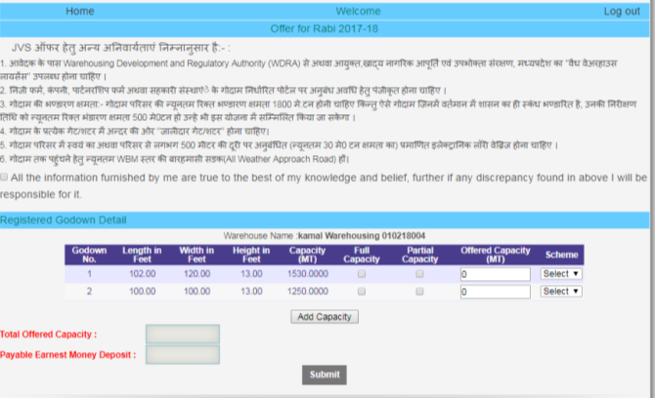

User has to accept all the conditions as mentioned in Offer Application by Checking On the check box of button.

User may offer the capacity for each registered godown under type of scheme. The capacity may be full of partial, In case of partial offering, the offered capacity need to be entered.

ON clicking add to capacity the Total offered Capacity and Payable Earnest money deposit will be automatically calculated by the system and displayed.

On clicking Submit Button, a receipt of offered capacity will be generated and available for user reference,

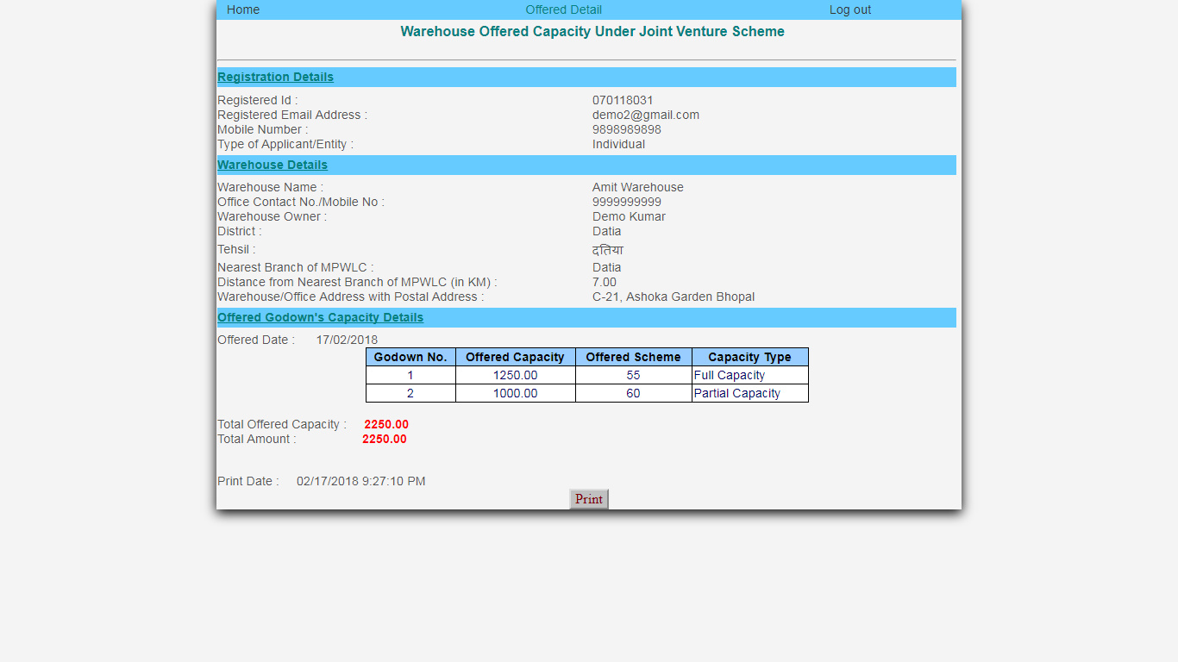

OFFERING – FEE PAYMENT

Once user has Offered the capacity for Warehouse / Godown, he / she is now able to pay the offer fee ( Earnest money Deposit) for the offered capacity of Warehouse / Godown.

User has to login and open the screen or go to home button( if already logged in), the Home screen will look like as follows:-

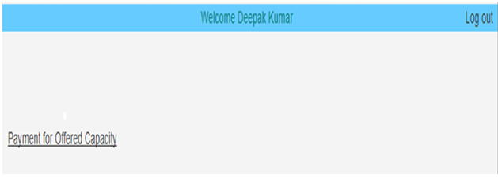

Similar process as defined in Section 4 for Registration Fee will be adopted. The only change in the process is that Instead of Registration Fee now we have to use the offered quantity.

